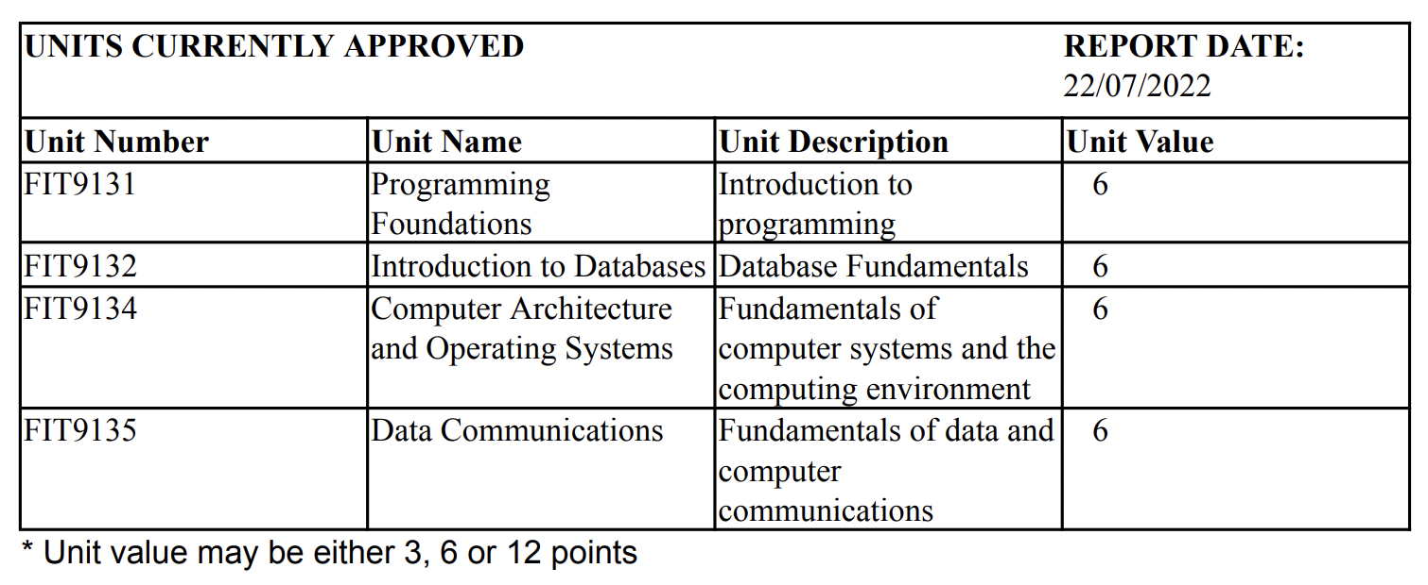

No repeating groups in the table.

UNF

UNITS(unit_number, unit_name, unit_description_unit_value)

1NF

* Identify the composite keys (a unique id). Hence, candidate keys are:
* Unit_number
* Unit_name (can have the same name)
* Unit_description (can have the same description)

UNITS(unit_number, unit_name, unit_description_unit_value)

**Partial dependency (you look at the candidate keys for partial dependences)**

To get from 1NF to 2NF, you need to find partial dependencies (one of the attribute in the composite key determines a non-key attribute).

* None

2NF

UNIT(unit_number, unit_name, unit_description_unit_value)

**Transitive Dependency**  
**non-key is everything except in candidate keys**

To go from 2NF -> 3NF we use transitive dependencies (non-key attribute depends on another non-key attribute, which in turn depends on the primary key).

Transitive Dependency

* None

UNIT(unit_number, unit_name, unit_description_unit_value)

Full dependencies

Unit_number -> unit_name, unit_description, unit_value

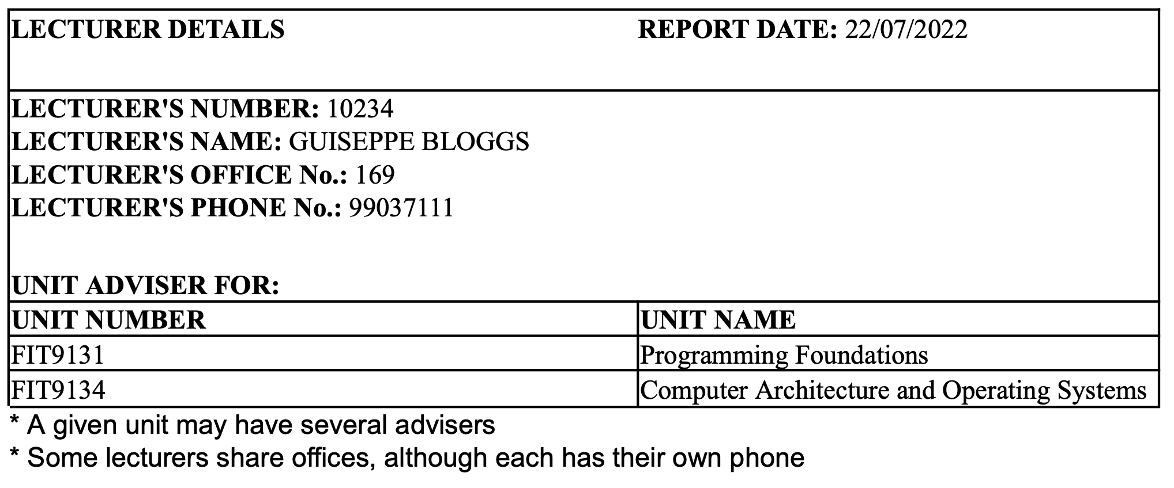

Repeating group is unit_number and unit_name.

unit_name can repeat, so it is not a composite key.

UNF

LECTURER_DETAILS(lecture_number, **lecture_frame, lectire_lname**, lecture_office_no, lecture_phone_no, (unit_number, unit_name))

1NF

LECTURER_DETAILS(lecture_number, **lecture_frame, lectire_lname**, lecture_office_no, lecture_phone_no, (unit_number, unit_name))

* (1) Remove repeating group
  + LECTURER_DETAILS(lecture_number, **lecture_frame, lectire_lname**, lecture_office_no, lecture_phone_no, (unit_number, unit_name)) ->
    - LECTURER_DETAILS(lecture_number, **lecture_frame, lectire_lname**, lecture_office_no, lecture_phone_no)
    - UNIT(unit_number, unit_name)
  + Candidate keys
    - Lecture_no
    - Lecture_phone
    - ~~Lecture_office~~
    - Lecture_no, unit_number
  + Integrate candidate key into repeating group relation (we choose lecture_no as PK)
    - LECTURER_DETAILS(lecture_number, **lecture_frame, lectire_lname**, lecture_office_no, lecture_phone_no)
    - LECTURER_UNIT(lecture_number, unit_number, unit_name)
  + Note: PK is not unique, because unit can have multiple lecturers. Hence, unit_no is not enough to uniquely identify it. We also want lecture_no as PK as well. Thus, we take lecturer_name as a PK to make it composite and uniquely identifiable.

Partial dependencies **occurs when one primary key determines some other attribute/attributes**:

~~lecture_number - > lecture_name~~

Unit_number -> unit_name

2NF

LECTURER(lecture_number, lecture_frame, lectire_lname, lecture_office_no, lecture_phone_no)

LECTURER_UNIT(lecture_number, unit_number)

UNIT(unit_number, unit_name)

Transitive dependencies **occurs when some non-key attribute determines some other attribute**:

None

3NF

LECTURER(lecture_number, lecture_frame, lectire_lname, lecture_office_no, lecture_phone_no)

LECTURER_UNIT(lecture_number, unit_number)

UNIT(unit_number, unit_name)

Full dependencies **occurs when the full key is required (all columns of the key) to determine another attribute**:

* lecture_number -> lecture_fname, lecture_lname, lecture_office_no, lecture_phone
* unit_number -> unit_name

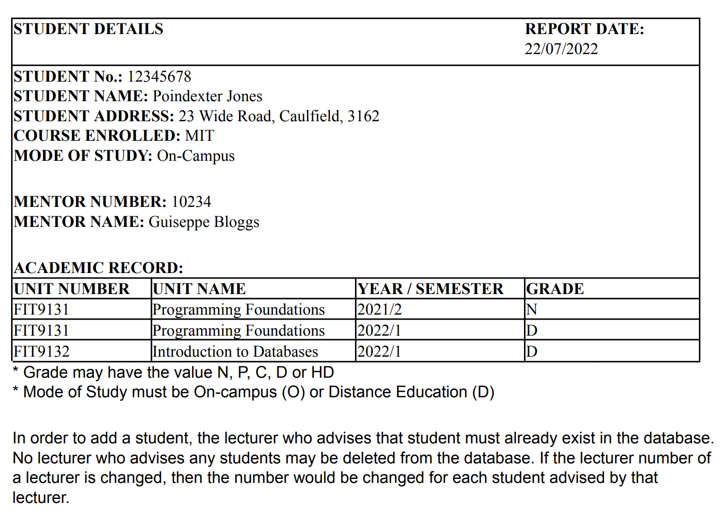

Repeating group is academic record

STUDENT_DETAILS(student_no, student_name, student_address, course_enrolled, more_of_study, mentor_number, mentor_name, unit_number, unit_name, year, grade)

**Decompose student_name into student_fname and student_lname**

STUDENT_DETAILS(student_no, student_fname, student_lname, student_address, course_enrolled, more_of_study, mentor_number, mentor_name, unit_number, unit_name, year, grade)

UNF

STUDENT_DETAILS(student_no, student_fname, student_lname, student_address, course_enrolled, more_of_study, mentor_number, mentor_name, (unit_number, unit_name, year, grade))

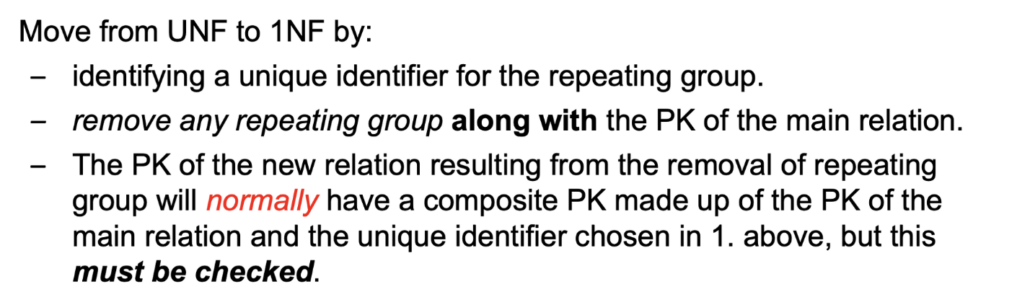

UNF -> 1NF:

STUDENT_DETAILS(student_no, student_fname, student_lname, student_address, course_enrolled, more_of_study, mentor_number, mentor_name)

ACADEMIC_RECORD(student_no, unit_number, unit_year, unit_sem, unit_name, grade)

Don’t combine candidate key from STUDENT with repeating groups.

Candidate keys:

student_no

Student_no,unit_no, unit_year, unit_sem

**Partial dependency (you look at the candidate keys for partial dependences)**

To get from 1NF to 2NF, you need to find partial dependencies (one of the attribute in the composite key determines a non-key attribute).

* Unit_number -> unit_name

2NF

STUDENT_DETAILS(student_no, student_fname, student_lname, student_address, course_enrolled, more_of_study, mentor_number, mentor_name)

ACADEMIC_RECORD(student_no, unit_number, unit_year, unit_sem, unit_name, grade)

UNIT(unit_no, unit_name)

**Transitive Dependency**

To go from 2NF -> 3NF we use transitive dependencies (non-key attribute depends on another non-key attribute, which in turn depends on the primary key).

Transitive Dependency

* lecture_no -> lecture_fname, lecture_lname

3NF

STUDENT_DETAILS(student_no, student_fname, student_lname, student_address, course_enrolled, more_of_study, mentor_number, mentor_name)

ACADEMIC_RECORD(student_no, unit_number, unit_year, unit_sem, unit_name, grade)

UNIT(unit_no, unit_name)

LECTURER(lecture_no, lecture_fname, lecture_lname)

**Full dependencies**

student_no -> student_fname, student_lname, student_address, course_enrolled, more_of_study, mentor_number, mentor_name)

student_no, unit_number -> unit_year, unit_sem, unit_name, grade)

unit_no, -> unit_name

lecture_no -> lecture_fname, lecture_lname

**Relations**

1. STUDENT(student no, student fame, student Iname, student address, student course, student mode, lecture_no)

2. ACADEMIC_RECORD(student no, unit no, unit year, unit sem, unit grade)

3. UNIT (unit no, unit name)

4. LECTURER(lecture no, lecture fname, lecture _ Iname)

5. LECTURER(lecture no, lecture _ fname, lecture_ Iname, lecture_office_no, lecture phone)

6. LECTURER_UNIT(lecture no, unit no)

7. UNIT (unit no ‚unit name)

8. UNIT(unit no, unit name, unit description, unit value)

**Final Relations:**

3,7&8: UNIT(unit no, unit name, unit [description, unit_value)

4&5 : LECTURER(lecture no, lecture_ fame, lecture Iname, lecture_ office _no, lecture phone)

LECTURER UNIT(lecture no, unit no)

STUDENT(student no, student fame, student Iname, student address, student_ course, student mode, lecture no)

ACADEMIC_RECORD(student_no, unit_no, unit_year, unit_sem, unit_grade)

Attribute synthesis

collect all similar relations

1. UNIT(unit_number, unit_name, unit_description_unit_value)
2. LECTURER(lecture_number, lecture_frame, lectire_lname, lecture_office_no, lecture_phone_no)
3. LECTURER_UNIT(lecture_number, unit_number)
4. UNIT(unit_number, unit_name)
5. STUDENT_DETAILS(student_no, student_fname, student_lname, student_address, course_enrolled, more_of_study, mentor_number, mentor_name)
6. ACADEMIC_RECORD(student_no, unit_number, unit_year, unit_sem, unit_name, grade)
7. UNIT(unit_no, unit_name)
8. LECTURER(lecture_no, lecture_fname, lecture_lname)

**Look for relations with the same PK, then they are the same relation.**

We see that number (3), (7) and (8) have same PK; UNIT(unit_number, unit_name)

(3) and (8)

LECTURER_UNIT(lecture_number, unit_number)

LECTURER(lecture_no, lecture_fname, lecture_lname)